Echolocation final report

Jai Kothari (JK) – P2566248 – Project Manager

Oskar Kojder (OK) – P2549004

Romans Kononovs (RK) – P2530667

Vinushan Vickneswaran (VV) – P2449187

Contents

Introduction 2

Project Management 3

Implementation 4

The Art 4

The Menus 4

The Scripts 4

The Sounds 4

The Levels 4

Prototype Walkthrough 5

User Evaluation 7

Discussion and Conclusions 8

# Introduction

We used this GDD as we felt that it was the simplest to implement and expand on when it came to using Unity. Draft assets and textures had already been created, needing minimal tweaks, and the group could easily gain the knowledge of how the game is supposed to work after reading the GDD. We used the flowcharts in the GDD to design core elements of the game such as the menu system.

The game is called ‘Echolocation’ and it follows the premise of using senses other than your vision to navigate the map. There are different levels and dangers that the player must avoid, with visual and sound effects to accompany this.

Having survived a crippling epidemic that has taken over your small village, you must help those in need by venturing into the dangerous cave system to retrieve a cure, the rare Bell Flower. Trapped in complete darkness, you must use your incredible skill of using visualised sound to guide yourself through the cave system and retrieve the Bell Flower. The sounds you create through moving, stomping and throwing rocks will reveal the shape of the surrounding world but only until they dissipate. It won’t be long until the only way of sensing the cave system alerts and attracts the inhabitants of the cave who are hungry for their next meal.

# Project Management

We began planning on this project by meeting on a Saturday in person, where we set up GitHub as our main development tool and made sure every member of the group was familiar with using git. We then decided to have an online meeting every Saturday, with the first meetings finalising the first roles that each group will undertake in the project.

Weekly voice chat meetings over Discord have been very successful as we were able to report back on our collective progress and discuss any issues we have come across. It also allowed us to reassign tasks to different group members if they were better equipped to handle it. New tasks were decided in these meetings and usually expected to be completed by the next Saturday, so that feedback is ready in the meeting on Saturday. As the meetings were already taking place online, the COVID-19 pandemic did not largely affect the group’s communications. Work on the project was able to be continued unimpeded until a new date was announced, at which point the group decided to improve on the prototype.

Outside of these meetings, the group has been in constant communications via text chat on Discord and a WhatsApp group chat. This allowed quick questions and answers amongst members while the project was being developed, with easy collaboration for difficult tasks. Text chat was used to coordinate designing and implementing the levels, and this would have caused confusion if each member of the group did not fully understand what to do before the next meeting. Text chat was once again vital during the pandemic as it was the only other way the group could stay in touch and know when to push/pull changes from the GitHub servers.

At the end of every meeting, minutes were kept and have been submitted in the Project Management report along with the Gantt Chart we created in the first week, that was updated each week.

# Implementation

## The Art

The art, which includes the shoes, the enemies and the maps, were created with Adobe Illustrator and planning was done on pen and paper. The font was created in Adobe Illustrator and converted into a font type using <https://www.calligraphr.com/en/>.

## The Menus

The menu system was largely implemented using the button component, and the component was configured to turn the text colour red on hover and to turn black (fade in with background) on click. All text in the game is the custom font developed specifically for the project to give it an eerie look. The start and pause menu will both have eerie music in the background to give the user more suspense.

## The Scripts

Many scripts had to be developed for the game. When planning, the group did not foresee the number needed. However, all the scripts make the game playable. The movement of the player is controlled through a script. The line changing mechanic is done using the scripts. Even the menu systems needed scripts for them to be functional.

## The Sounds

Within the levels, there are sounds to describe events occurring to the player. An example is the puddle sound if the player steps into water, alerting the player so they can change course. Sounds were created with a verity of software, such as BeepBox to make the title music and Audacity to record the footstep sounds.

## The Levels

The levels were made of a selection of the group’s level roster. There were roughly 30 levels that were thought of, but due to time restraints the group decided to pick 9 to make. The rest of the levels can now be developed rather quickly due to a script that allows a tile map to be created.

# Prototype Walkthrough

When a user launches the prototype, they will be presented with a menu screen. When the user selects New Game, they will begin on the first level. Using the arrow keys to move, the player must navigate the level and collect the Bell Flowers, before finding the exit to move to the next level. In complete darkness, the player can briefly see more of their surroundings by pressing the space bar to perform a Stomp. It will show the layout of the level and using this ability the player must collect the flower and find the exit to enter the next level. There are 9 levels in total in this prototype.

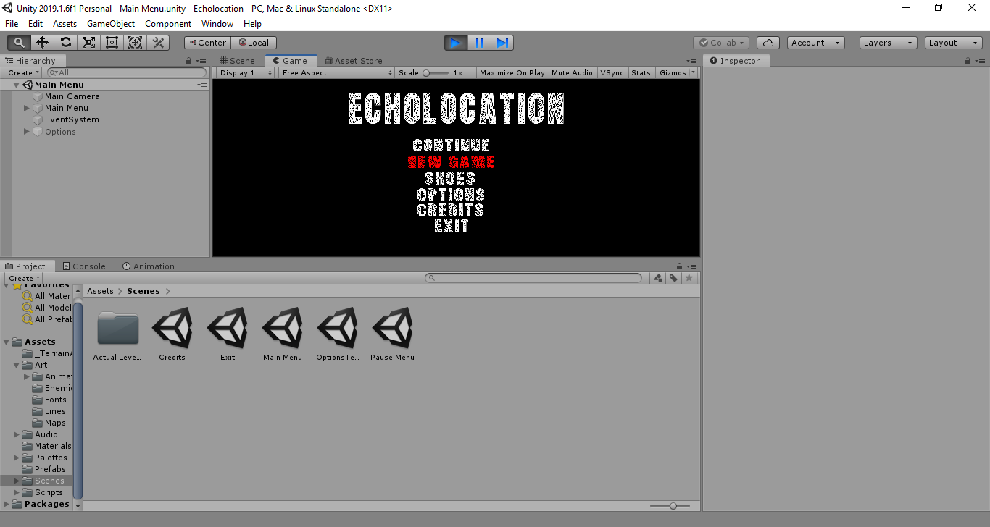

The main menu, with the mouse hovering over ‘New Game’

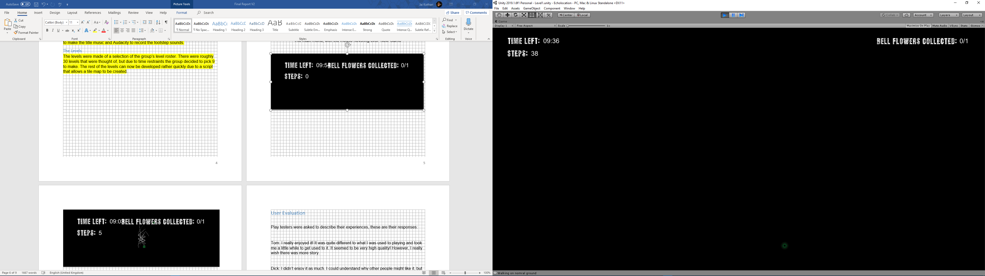

The UI of the game.

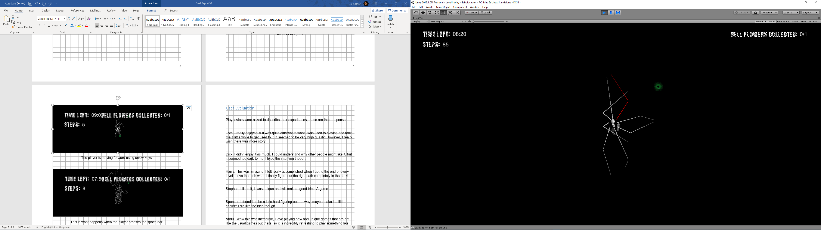

The player is moving forward using arrow keys.

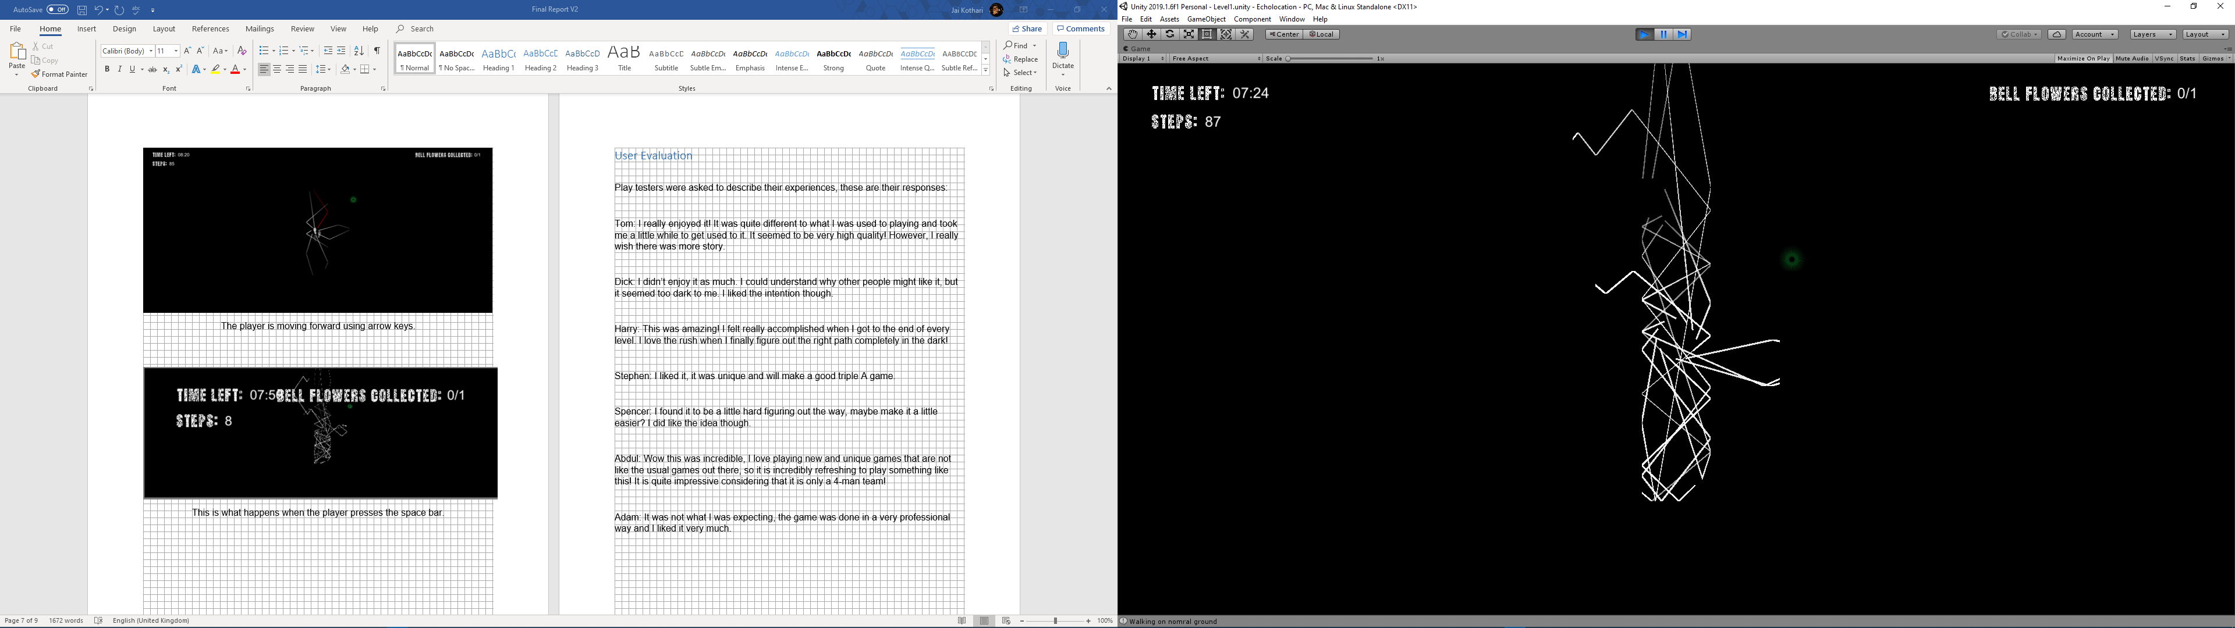

This is what happens when the player presses the space bar.

# User Evaluation

Play testers were asked to describe their experiences, these are their responses:

Tom: I really enjoyed it! It was quite different to what I was used to playing and took me a little while to get used to it. It seemed to be very high quality! However, I really wish there was more story.

Dick: I didn’t enjoy it as much. I could understand why other people might like it, but it seemed too dark to me. I liked the intention though.

Harry: This was amazing! I felt really accomplished when I got to the end of every level. I love the rush when I finally figure out the right path completely in the dark!

Stephen: I liked it, it was unique and will make a good triple A game.

Spencer: I found it to be a little hard figuring out the way, maybe make it a little easier? I did like the idea though.

Abdul: Wow this was incredible, I love playing new and unique games that are not like the usual games out there, so it is incredibly refreshing to play something like this! It is quite impressive considering that it is only a 4-man team!

Adam: It was not what I was expecting, the game was done in a very professional way and I liked it very much.

# Discussion and Conclusions

As mentioned, we had planned to have a meeting every Friday to discuss progress on the project and to assign new roles/catch up on current roles. This has worked well, even during the pandemic as we have used the chat app Discord to maintain these meetings. Through this weekly meeting process, we have achieved an organised way of building a working prototype and we have used the appropriate lifecycle method.

The prototype is a very faithful clone of the game imagined in the GDD. Some of the minor differences include the footsteps not being in red as described in the GDD. In the project itself, we have chosen to have white footsteps as it was a better fit in front of a full-black background.

We feel that the implementation of our designs were very easy as the group was able to fully understand the planned mechanics by reading the very detailed GDD. Communication as mentioned was not lost between the group members which enabled us to continue working on the project with little delay. We found it very easy to inform each other on our progress and issues we may have come across, however at times the roles were mismatched, and we have had to reorganise this by reassigning to a different group member. Overall using online communications has been very helpful in having fast solutions to problems like these and we have been able to continue development with little delay.

The outcomes of the user evaluation showed that we have achieved in creating a unique and interesting game, albeit with some drawbacks. One of the flaws mentioned was that it was too ‘dark’ which can be attributed to the fact that the game is set in a dark setting to illustrate the player not having their vision. This is a hard point to work on, however if we were to improve on this feedback, we would try to use brighter colours in other areas of the game such as the pause menu. While it is impossible to use light colours to demonstrate no vision, using different colours in various aspects of the game (outside of the levels e.g. pause menu) may ease the player’s experience. We are mostly happy with some mentions of ‘high quality’ work, which confirms to us that the player experienced little to no bugs in-game and enjoyed testing.

To conclude, the Echolocation prototype has been created through successful group collaboration using online means and regular meetings to discuss and evaluate progress and next steps.